Employee Workforce Data Analytics Project

1. Problem Statement
The objective of this project is to analyse a company's employee dataset containing approximately 1,500 records. The project focuses on employee details, salary, attendance, performance, and training.
The dataset is cleaned and analysed to identify important trends, patterns, and anomalies. An interactive Power BI dashboard is created to present the findings clearly and help management make better, data-driven decisions.
Project Objectives:
- Clean and prepare the dataset.
- Analyse employee data using statistics and charts.
- Identify trends and unusual values.
- Create an interactive Power BI dashboard.
- Provide useful business insights.

2. Dataset Information
The dataset contains approximately 1,500 employee records from a company. It includes information about employees, payroll, attendance, performance, and training.
The dataset is organized into five sheets:
- Employees: Employee details and experience.
- Payroll: Salary and compensation information.
- Attendance: Employee attendance records.
- Performance: Employee performance details.
- Training: Employee training and completion records.
The dataset is used to analyse workforce information, identify patterns, and create an interactive Power BI dashboard for better decision-making.

3. Data Cleaning Process
The dataset was cleaned before analysis to improve data quality and accuracy. The following steps were performed:
- Removed Missing Values: Rows containing missing values were removed.
- Checked Data Quality: The dataset was reviewed for errors and inconsistencies.
- Verified Employee IDs: Employee IDs were checked to maintain consistency across different sheets.
- Prepared Data for Analysis: The cleaned data was organized for further analysis and visualization in Power BI.
These steps helped prepare the dataset for accurate analysis and dashboard creation.

4. Exploratory Data Analysis (EDA)
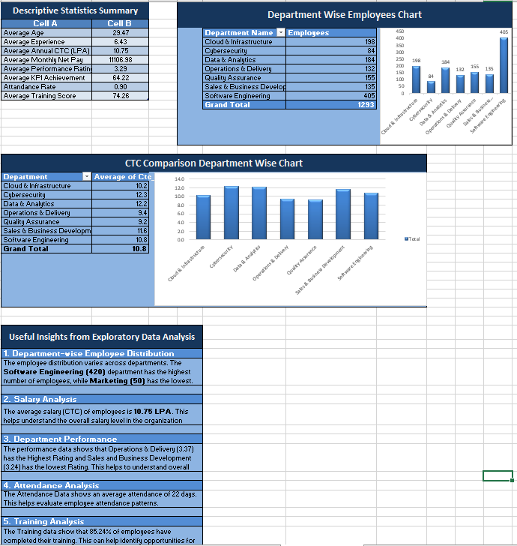
Exploratory Data Analysis was performed on the cleaned employee dataset to understand workforce patterns and identify useful information.

The analysis focused on:
- Employee Analysis: Understanding the total number of employees and their experience.
- Salary Analysis: Examining employee salary and CTC distribution.
- Attendance Analysis: Reviewing employee attendance records.
- Performance Analysis: Understanding employee performance patterns.
- Training Analysis: Analysing training completion among employees.
Charts and statistical summaries were used to identify trends, compare categories, and highlight areas for improvement.

5. Power BI Dashboard
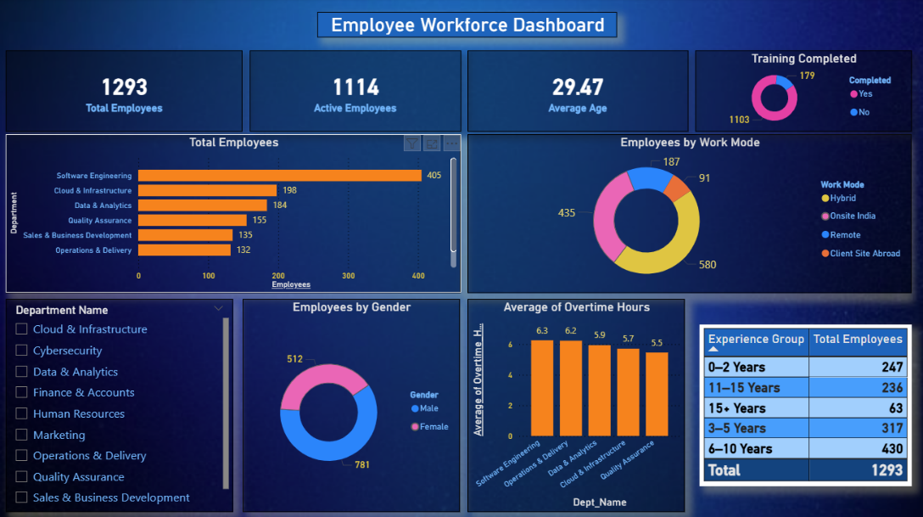
An interactive dashboard was created using Microsoft Power BI to present the employee data in a clear and visual format.

The dashboard includes key performance indicators (KPIs), charts, and graphs to analyse:
- Total Employees
- Employee Experience Distribution
- CTC Distribution
- Training Completion
- Employee Workforce Patterns
The dashboard helps users understand important information quickly, compare different categories, and identify trends for better decision-making.

6. Key Business Insights
The employee data analysis and Power BI dashboard help identify important workforce patterns.
- Employee Distribution: Understand the total workforce and employee experience levels.
- Salary Analysis: Identify salary and CTC distribution across employees.
- Attendance Monitoring: Review employee attendance patterns and identify possible attendance issues.
- Performance Evaluation: Analyse employee performance to identify areas for improvement.
- Training Completion: Monitor training completion and identify employees who may need further training.
These insights can help management improve workforce planning, monitor employee performance, and make better data-driven decisions.

